SMART WASTE MANGEMENT SYSTEM FOR METROPOLITAN CITIES USING IOT

TEAM ID :PNT2022TMID44727

TEAM MEMBERS: KOKILAVANI P (732519106008)

PRASANTH AK (732519106016)

UMA ABIRAMI A (732519106019)

VASANTH N (73257106020)

DEPARTMENT ECE

COLLEGE NAME SHREE VENKATESHWARA HI-TECH

ENGINEERING COLLEGE

FUNCTIONAL REQUIREMENTS

Store your waste – depending on the type of waste, there will be different requirements in terms of storage facilities.

• Controlling access to the containers.

• Protecting the containers from the elements.

• Storing containers of liquid waste on a curbed and impermeable surface to contain accidental leaks.

• . Municipal Solid Waste (MSW):

• b. Hazardous Wastes:

• c. Industrial Wastes:

• d. Agricultural Wastes:

• e. Bio-Medical Wastes:

• f. Waste Minimization:

NON FUNCTIONAL REQUIREMENTS

generation

storage

collection

transportation

processing

recycling and disposal

• The process is not always cost-effective: ...

• The resultant product has a short life: ...

• The sites are often dangerous: ...

• The practices are not done uniformly: ...

• Waste management can cause more problems: ...

• 4 Old School Business Processes to Leave Behind in 2022.

DATA FLOW DIAGRAM

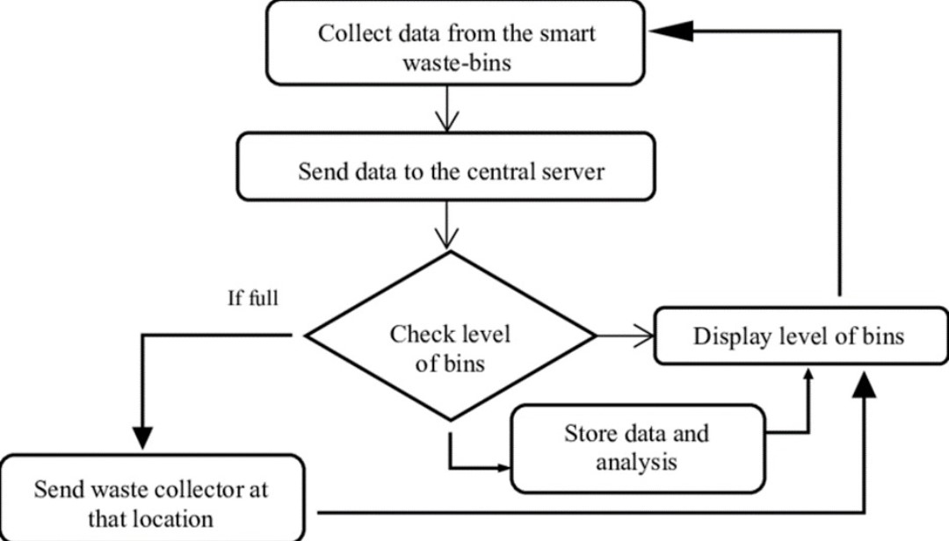

ARCHITECTURE DIAGRAM

